Implementation of Restorative Practices in the Brighton Central School District

HISTORY
August 2018

Brighton High School started to look into R.P. and how it might be affective. District members had traveled to NYC and toured schools where Restorative Practices and Restorative Discipline were being utilized.
Why Restorative Practices?
1. Wrong doing takes place and relationships need to be repaired
2. Build social capital
- Invest in relationships and you get more out when you need it
- Find out what the kids are doing, take an interest, form relationships with them, share, talk, listen.
- Restorative Practices is a philosophy

3. Restorative Practices in schools
- Build relationship
- When issues take place, how can it be put back on the student so they take responsibility and are then part of the solution
- Restoration - Repair the harm that has been caused
- Reintegration – Student returns to the environment and feels good about it

BHS met with representatives from Partners in Restorative Initiatives to learn about training in Restorative Practices and ordered resources (Circle Forward) to learn more about it.

Partners In Restorative Initiatives (PIRI)
  - Established in 1998 by Will Bontrager
  - Uses different strategies and circles to build relationships, build community, and repair harm in schools, communities, and the justice system
  - Benefits of Restorative Practices:
    - Build/strengthen relationships
    - Repair harm
    - Restore peace to families and communities
    - Reduce violence
    - Promote healing
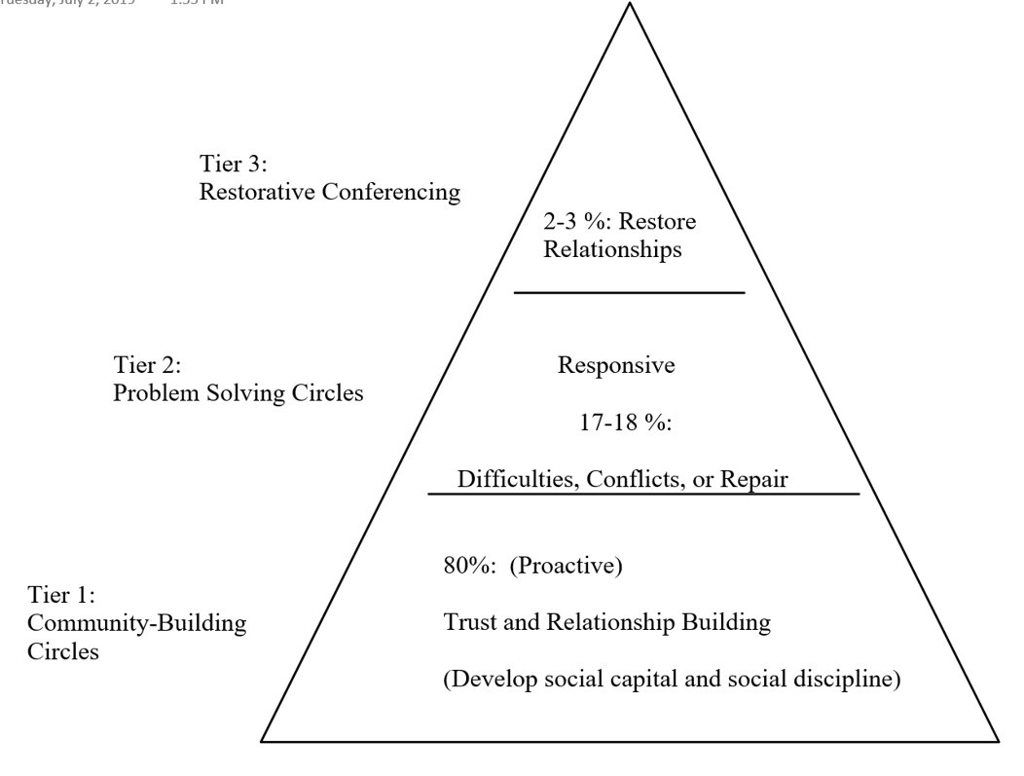

BHS brainstormed an outline for implementation, District-wide:
- Create a team for Restorative Practice and outside groups to assist
- All Assistant Principals and counselors were on board with pursuing this
- At BHS (specifically):
  - Established a Professional Learning Team to further investigate RP in January of 2019
  - PIRI would present to BHS
  - Conversation about when R.P. would be ready to be rolled out, District-wide
  - Map an outline for future implementation and practice

June, 2019
Action Steps:
- The Leadership Team will research discipline data in order to better understand equity issues discipline for all student groups.
- The Leadership Team will review current practices and make recommendations for change in practice going forward.
- The Leadership Team will research Restorative Justice programs formally while continuing to utilize informal restorative practices previously instituted.

Summer 2019
3-Day Training at PIRI (Teachers, Administrators, and Teaching Assistants)
June – 20 people are trained
July/August – 22 people are trained

1-Day Training at PIRI (Administrators and Mental Health Staff)
    - July & August – 23 people are trained

District Professional Day Training (Kim Ball and Hennessey Lustica)
    - 20 additional teachers are trained
    - Based on interest in Restorative Practices

Blueprint Meeting in June 2019 (Brainstorm)
    - Implementation (3-5-year plan)
    - Training for all staff
    - Involving students, parents, Brighton Community
    - Sustainability

Decision is made for Initial Implementation
    - Additional training at PIRI on September 18 (train-the-trainer)
    - District-wide roll out would be on Superintendent's Conference Day (October)
    - District-level and building-level Restorative Practices committees would be established
    - The district would continue to work with PIRI to build internal capacity
    - Addition of verbiage on Restorative Practices in the District Code of Conduct (September 2019 BOE meeting):

Restorative Practices is a social science that studies how to build social capital and achieve social discipline through participatory learning and decision making. It is based in developing social and emotional capacity to create relationships. These practices may include peer mediation, community building sessions, student/staff mediations, etc. In Brighton, restorative practices may be used in conjunction with traditional discipline measures to repair harm and restore relationships. These practices provide a safe environment for people to communicate and express both feelings and emotions. Once trust and mutual understanding is built, individuals are often able to work through difficult situations and develop a greater respect and caring for all in the environment in which the conflict occurred. Restorative practices provide students an opportunity to engage in restorative conversations when conflict/code of conduct violations take place with other students or staff. Our goal is to have students and staff work together to repair relationships and to discover solutions to the conflict/problem, building essential skills for the future.
- (Adapted from pages 1-5 of the Community Building Circles booklet from PIRI)
Superintendent’s Conference Day: October 11, 2019
  - Rolled out Restorative Practices, District-wide
    - Goals:
    - All in attendance leave with an understanding of how to conduct a community or academic circle
    - Strengthen relationships/build community among faculty
  - Format for the day
    - TCMS and BHS – Met separately in their respective buildings
    - CRPS and FRES – Met together at FRES

Community Building Circles
    - Groups of 13-15 (combination of administrators, teachers, clerical staff, and teaching assistants)
    - Two facilitators for each group (trained by Partners In Restorative Initiatives (PIRI))
    - Three circles with different prompts, videos, chalk talk activity
Post-Conference Day Roll out, 2019 – 2020 (by building):
CR:
- Circles are used every morning (morning meetings)
- Counselors utilize the circle format when pushing in for classroom lessons
FRES:
- Implementing Second Step in every classes with lessons from teaching tolerance incorporated
- Teachers have a daily community circles
- Counselors and administration utilize restorative conversations
- Teachers utilize academic circles in their instruction
BHS:
- All seminars are being done in circles.
- Teachers requested that the mental health staff come in and assist with circles.
- Counselors used circles with the ACE students and with 8-go-9 students
- Community circles are being used weekly in the AIM program. Administrators are also engaging with students in having restorative conversations.
- R.P. is being used to repair harm when there are disciplinary issues.
TCMS
- After conference day, staff was eager to continue to get into groups and do circles. They used it as a community building tool.
- R.P. was used during portions of faculty meetings to build connections amongst staff
- The R.P. building-level committee meets regularly to come up with ways for both students and staff to build connections.

During the COVID-19 shut down:
- Administrators utilized the “circle” format for checking in with those who were present in Zoom meetings
- Teachers were able to do check-ins with students and, fortunately, had built connections during the year
- Mental health staff continued to run groups and counseling sessions on Zoom to keep connections going with students
- During the summer, the mental health staff revisited their practices to see how they could deliver services differently (remotely)

Social Emotional Learning – Summer 2020
- Mary Beth Elko (BOCES 1, Instructional Specialist) conducted professional development for the mental health staff in response to addressing the healthy development of students and how to create a school environment that prioritizes students’ emotional development, social maturity, and academic achievement.
- SEL also intentionally creates a work environment in which staff feels supported and empowered, builds trust, and can further develop their social emotional skills. For this reason, Mary Beth also presented to our K-12 faculty and staff on the conference day the day before school started.
- SEL, like Restorative Practices, is about building community and fostering supportive classroom environments. SEL also focuses on recognizing differences among various social and cultural groups and how students and teachers can use communication and social skills to effectively interact with others.

Going forward (2020-2021 and beyond)…

The Mental Health Steering Committee will continue to work on plans for continuing our work in the district around Restorative Practices and hopefully, have a subgroup (mental health staff and administrators) trained by PIRI in Restorative Discipline. The committee with then work on a plan for how Restorative Discipline will be used and implementation district wide.

The M.H. Steering Committee also recognizes the intersectionality between R.P., SEL, and culturally responsive pedagogy. We will continue to research SEL screening tools that help us to better identify student mental health needs and also work with other committees in the district to promote connections, build community, and promote cultural awareness.

