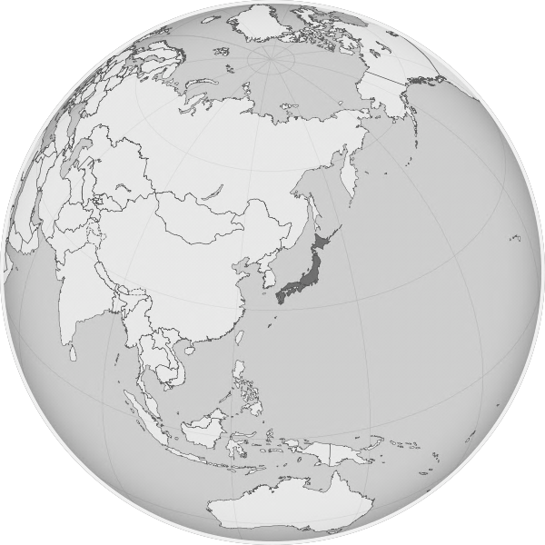
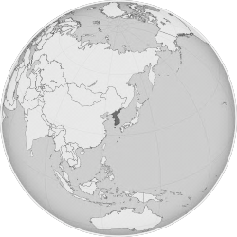
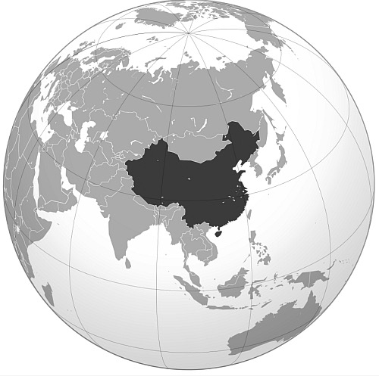
Mr. Clements / Ms. O’Shea:
Social Studies #9
Global History and Geography I
Unit VI: EAST ASIA
Homework Assignment Sheet

1. TEXTBOOK ASSIGNMENTS: READ ALL CHAPTER TEXTBOOK SECTIONS BELOW BUT COMPLETE POWER WRITE WORKSHEETS FOR ONLY THOSE SELECTED SECTIONS WHICH WILL BE ANNOUNCED AND POSTED IN CLASS. ASSUME THAT WE WILL DO SECTIONS IN THE ORDER THEY ARE PRESENTED BELOW. OUR TEXTBOOK IS: WORLD CULTURES: A GLOBAL MOSAIC

CHINA KOREA & JAPAN
CHAPTER 15: Sections 15.1 - 15.5 CHAPTER 17: Sections 17.1 - 17.2
CHAPTER 18: Sections 18.1 - 18.4
Note: Main Ideas for each section and Power Write Worksheets are available on my website.

2. EARLY CIVILIZATIONS, EMPIRES, DYNASTIES, & KINGDOMS ORGANIZER CHART:
Dynasties of China Chart
Early Kingdoms & Dynasties of China Chart
Early Dynastic Periods of Japan Chart

3. MAP PROJECTS: COMPLETE ALL MAP WORK AS INDICATED ON MAP PROJECT PACKET. MAP PACKETS WILL BE GIVEN TO YOU IN CLASS. WHEN APPLICABLE, A MAP QUIZ BASED ON MAP PACKET WILL BE GIVEN THE DAY MAP PROJECT IS DUE.
China Physical and Political Map Project and Quiz
Mongol Empire Map Project
Spheres of Influence in China Map Project
Japan/Korea Physical/Political Map Project and Quiz

4. CASTLE LEARNING ONLINE*: ONLINE MULTIPLE CHOICE REGENTS UNIT REVIEW QUESTION ASSIGNMENTS POSTED ON YOUR PERSONAL ACCOUNT. LOG IN USING
CLEVER PORTAL @ https://clever.com/in/brightonschools

China Unit Review Questions (80 Multiple Choice Questions)
Japan & Korea Unit Review Questions (70 Multiple Choice Questions)
* Available on-line for your convenience 24 hours a day and seven days a week!

5. UNIT PROJECT/S:
Regional Cultural Heritage Project
See my web page for details, due date and appropriate documents!

6. EAST ASIA UNIT TEST (Chapters 15, 17, & 18): A TEST WILL BE TAKEN AT THE COMPLETION OF THIS UNIT AND WILL INCLUDE ALL MATERIAL FROM THE ASSIGNED TEXTBOOK SECTIONS, CLASS INSTRUCTION, CASTLE LEARNING ASSIGNMENT/S, AND MAP PROJECT/S.

